Final project report

**Problem 2**

It took about 100 steps before the virus population stops growing.

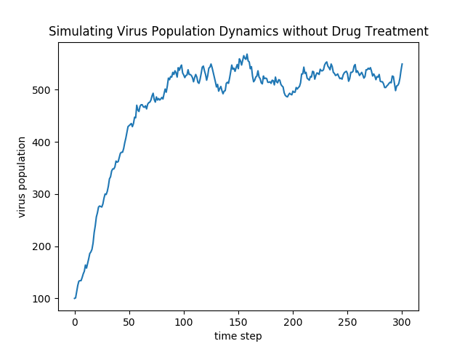

**Problem 4**

Before the drug is introduced, the number of Guttagonol resistant viruses is negligible, so the virus population fallen sharply when the Guttagonol is introduced. But after 200 time steps, the total virus population and the Guttagonol resistant viruses begin to increase. I thought it would return to a lower population. But what surprises me is that at the end of the simulation, the virus population return to the 500-600. Maybe it is because that the offspring acquiring resistance to Guttagonol from their parents only with a small mutation probability 0.05.

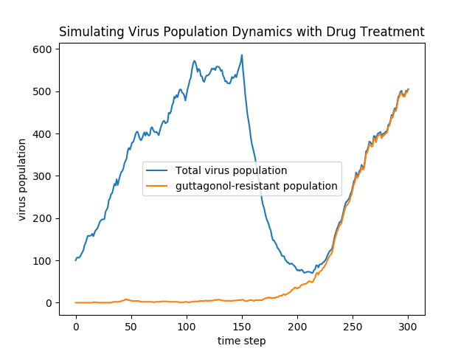

**Problem 5**

The number of patients is 200. We think 200 is enough to achieve a reasonable result. If we consider final virus particle counts of 0–50 to be cured, the percentage of patients were cured at the end of the simulation is as follows:

|  |  |
| --- | --- |
| **Delay in time**  **steps** | **% Cured or in remission <50 viruses** |
| 300 | 1.0% |
| 150 | 2.0% |
| 75 | 10.5% |
| 0 | 97.0% |

It is obvious that the longer treatment delay, the lower the cure rate.

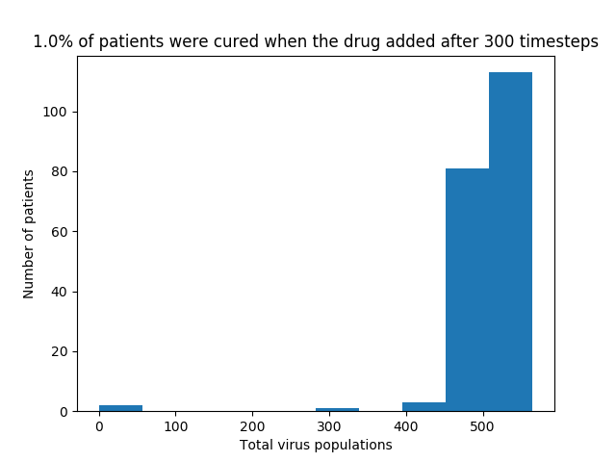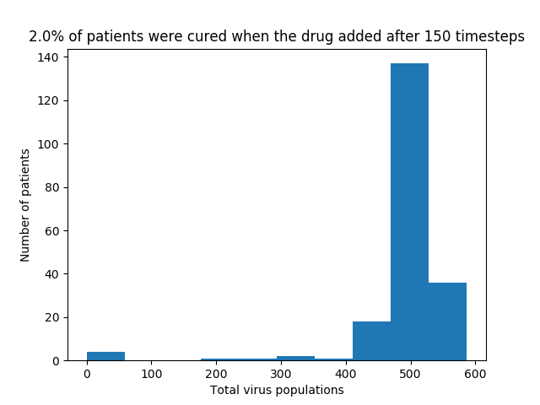

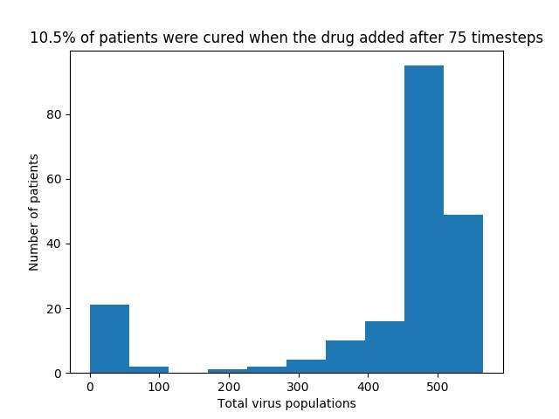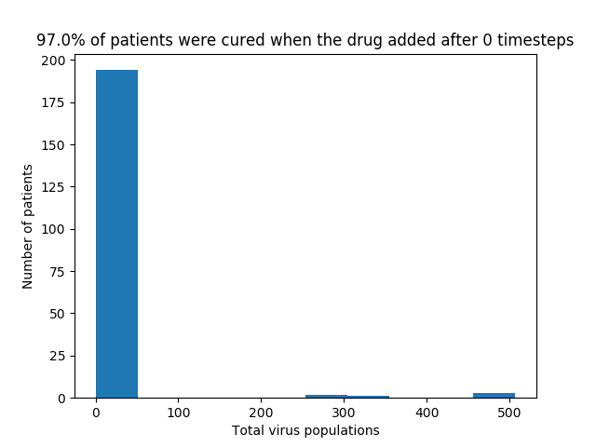

**Problem 6**

The number of patients is 30. If we consider final virus particle counts of 0–50 to be cured, the percentage of patients were cured at the end of the simulation is as follows:

|  |  |
| --- | --- |
| **Delay in time**  **steps** | **% Cured or in remission <50 viruses** |
| 300 | 3.3% |
| 150 | 13.3% |
| 75 | 30.0% |
| 0 | 80.0% |

It is obvious that the longer treatment delay between the two drugs, the lower the cure rate.

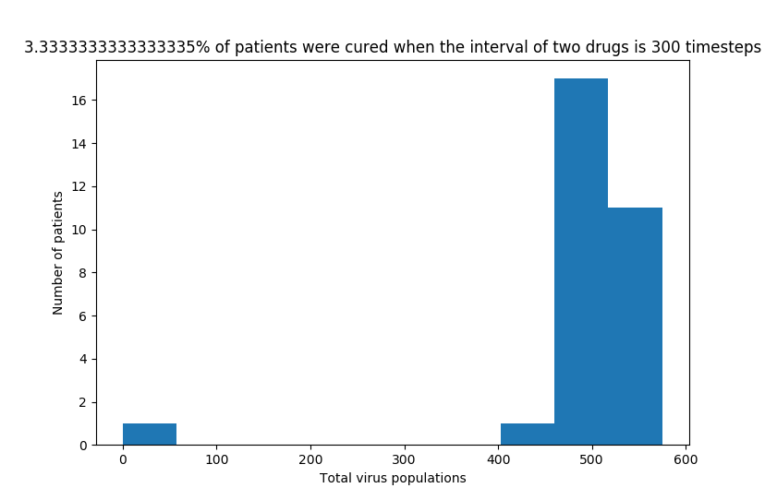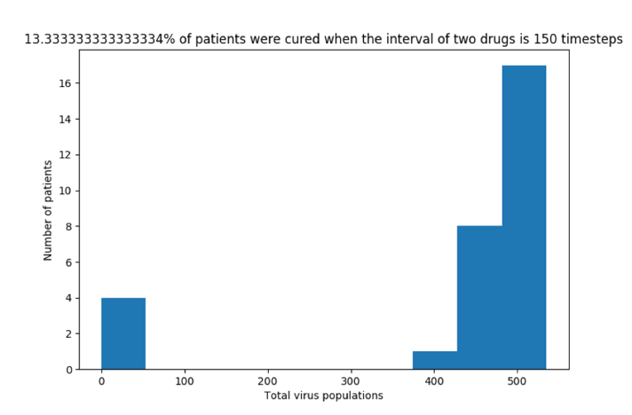

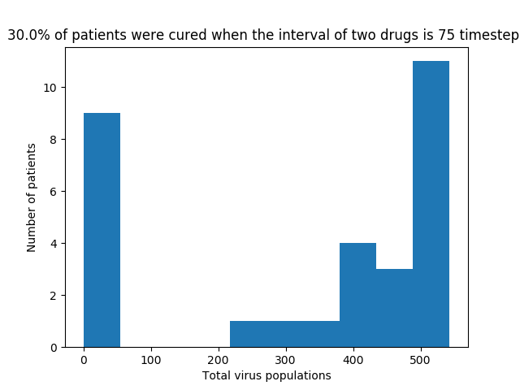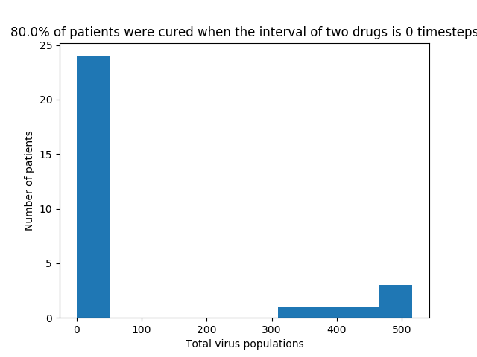

**Problem 7**

The first plot shows the simulation for an additional 300 time steps before administering a second drug, grimpex, to the patient. And the second plot shows the simulation for 150 time steps before simultaneously administering guttagonol and grimpex to the patient. The result of delayed treatment is worse. And in order to have a better treatment, the patients should take the combined drug without delayed treatment to inhibiting the growth of the virus.

